**Phase One Scholastic**

[**http://www.scholastic.ca/**](http://www.scholastic.ca/)

**Interaction Model**

The interaction model of Scholastic is very bad, it takes way too long to complete the task, if you are even able to complete the task you are trying to do. Scholastic has way too many claims and does not enforce one category enough, the design tends to be half finished and not worked on and updated often

**The user flow of this website**

The user flow I want to complete is buying a book,

To buy a book, you have to go to booksellers,

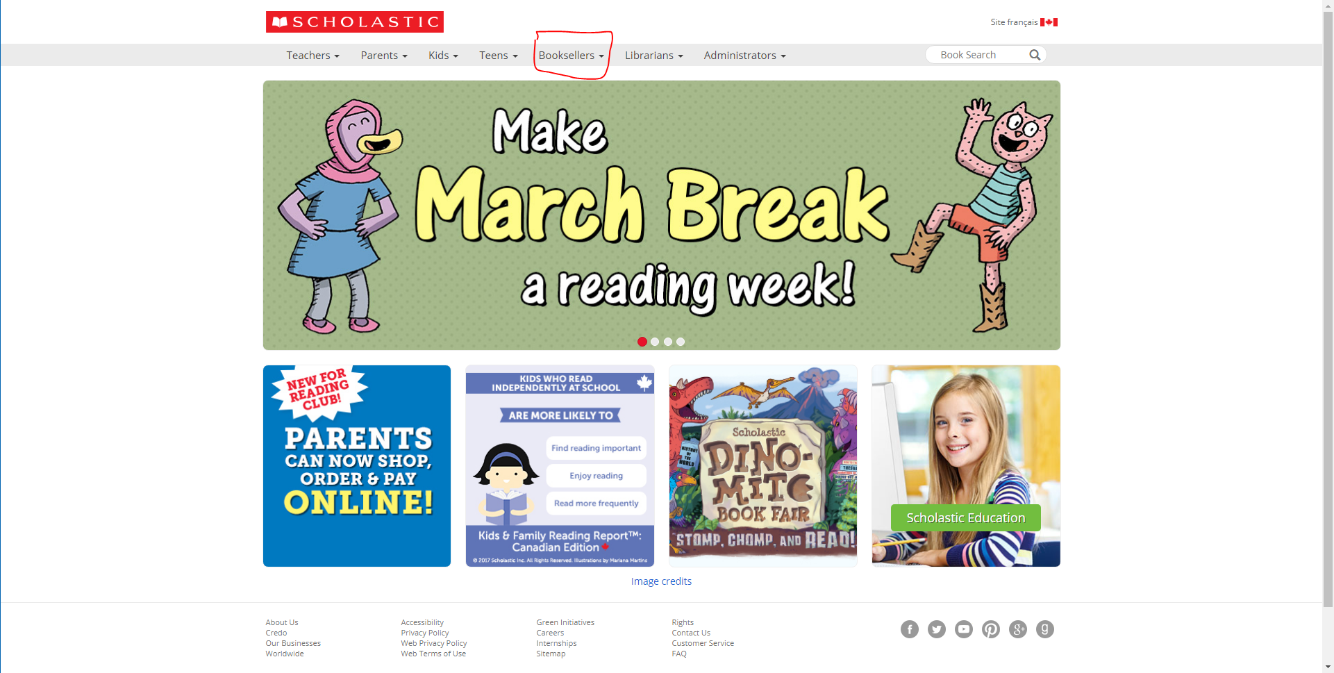

Then on the dropdown menu, click on the “trade Catalogues”, this is not the correct naming convention and really threw me off.

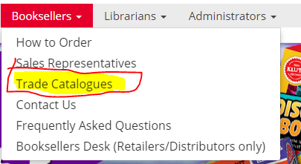

Once you get to the trade Catalogues, you choose a catalog, Scholastic expects you to have already looked at the catalog when you come here,so when you get to this page, you would have picked the books you want. My initial thought would be to click online order form (highlighted in yellor and red)

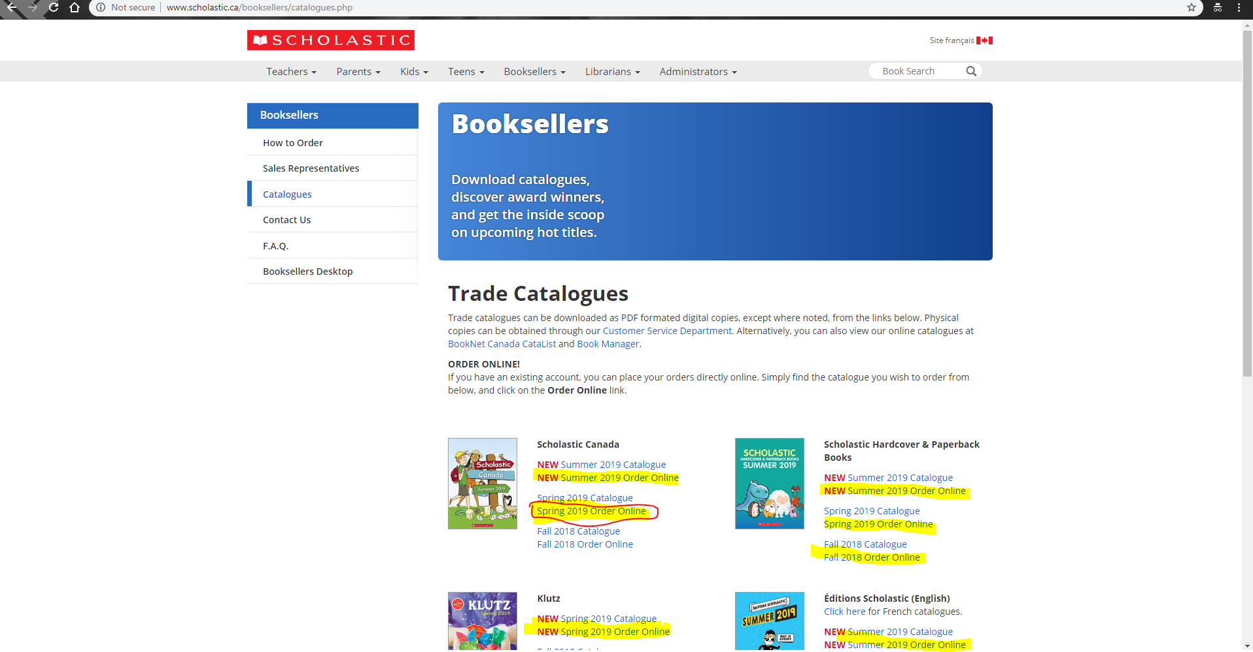

This page would bring you to the payment screen, but because you cannot order from this website without creating an account. (Which is not clear at all)

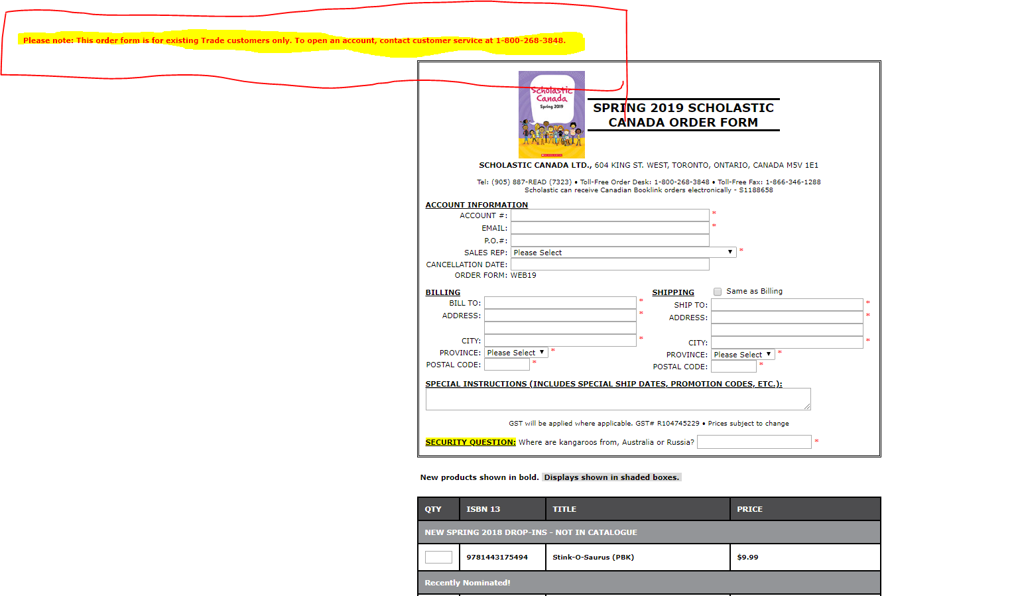

You would instead click on this link

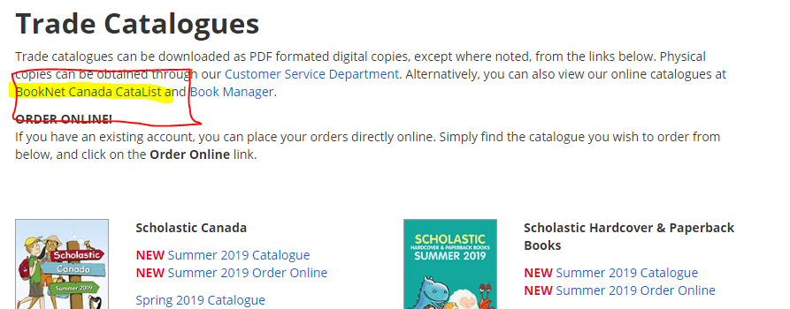

This link then brings you to another website, so you can purchase the books from there

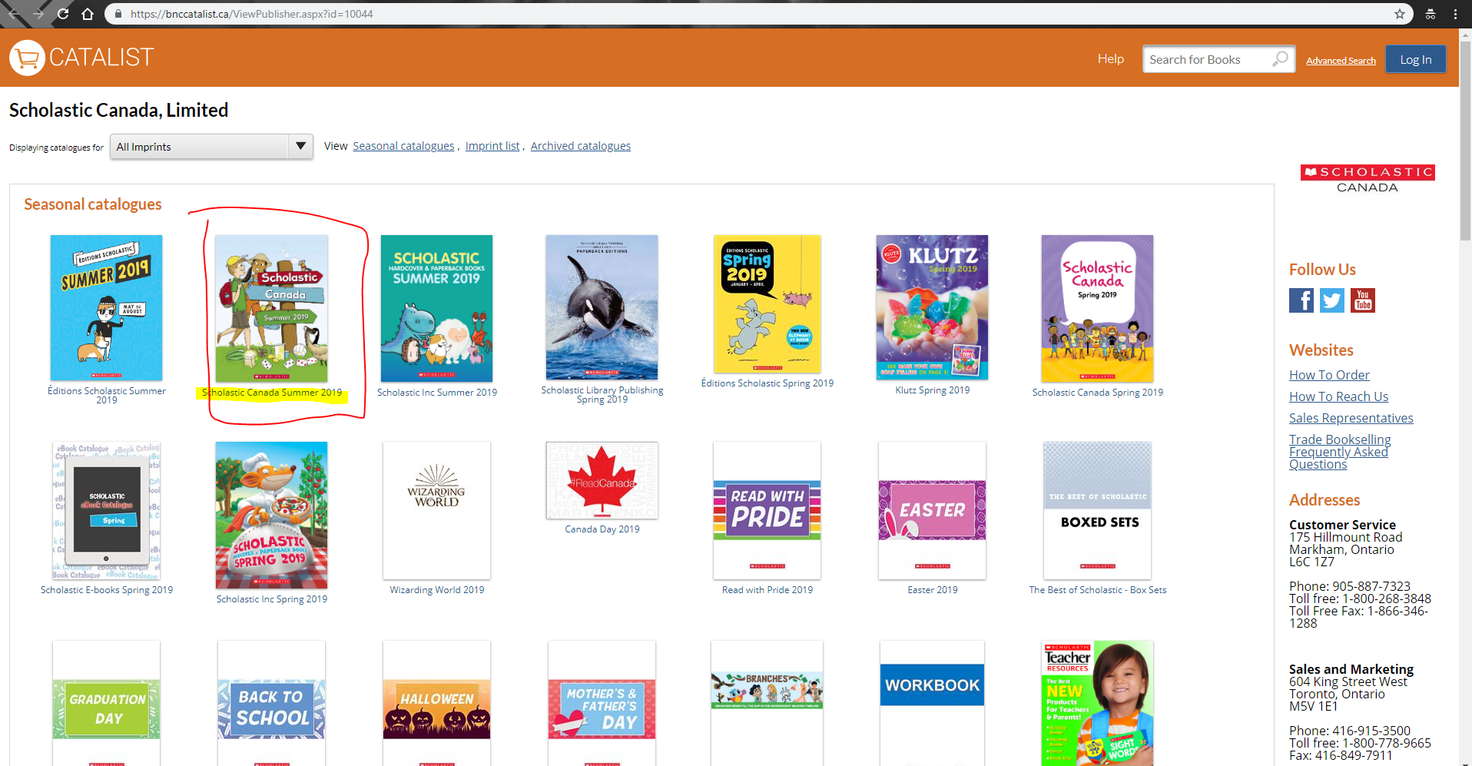

Then clicking on the Spring edition brings you to a page with the books inside, something that should have been done on the main website.

Then I click on the book

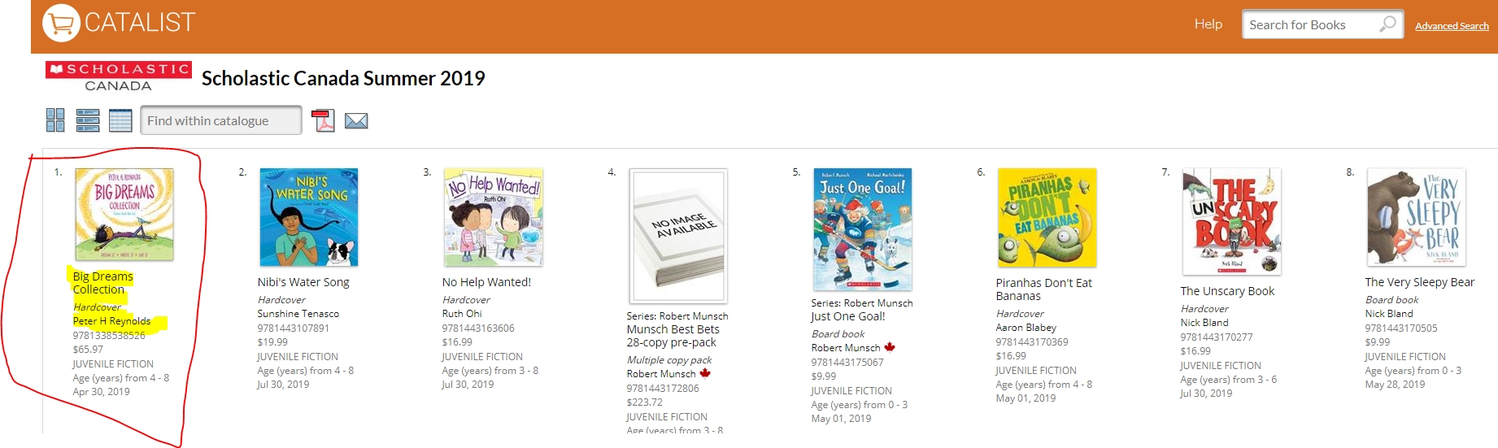

Only then did I realise that the Scholastic page does not support buying books because they do not have the purchasing icon, fluent throughout the enire rest of this new shopping website. this tells me as a buyer that there is no way to buy a book from scholastic other then ordering it by taking the time to call Scholastic and set up an account (note that other specific books searched, that were not Scholastic specific)did have the cart)

This is on CATALIST’s support page showing how to order books

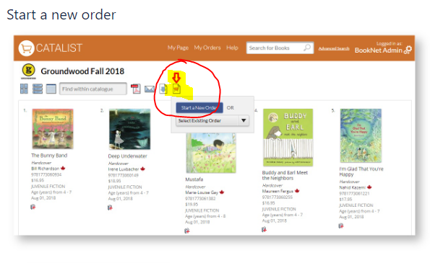

**2.** **Note ease of interaction with the site**

The ease of interaction on this website is really poor. On the main page, the only labels are on the nav bar, while the rest of the page is basically not needed because there are no labels for any links and the links lead to more links which would lead to a page that you could have seen in 2 clicks using the nav bar. This can be done a lot more efficiently. This being said, the website should have labels under the images, and keep things better spaced, it takes too many steps to complete some things and they can be reduced significantly by consolidating ways to get books onto one page, instead of making things into categories and putting things into the most popular and newest in the same page instead of them being on completely different pages. The site does not have a very nice flow and should be reconstructed by making things a lot simpler and having fewer pages to go through to find a new book or ones that are better selling books. But to get to see books for teens is made optimal and well, the one to kids was not and teachers the same.

**2. Ease Of Interaction Explained**

The interaction model of the website is all over the place, when I am to click a link on the main page, to find a book, it would take me to a completely different website all together,

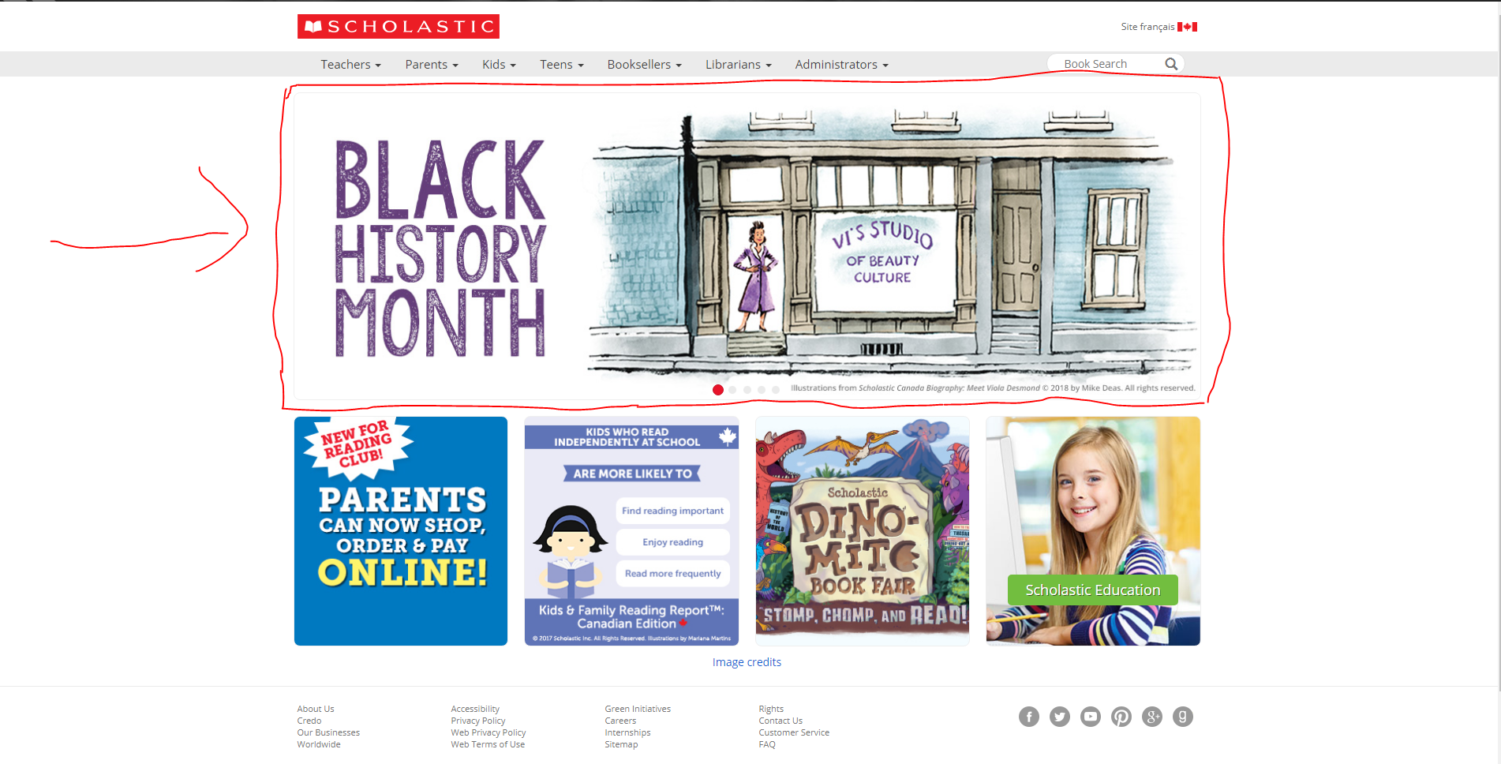

When you click this link, you would get to this screen, one major difference is that the margins on the side is completely different from the home of the website, this might caused me to get a bit overwhelmed because I was expecting to see a compressed amount of images, but got surprised

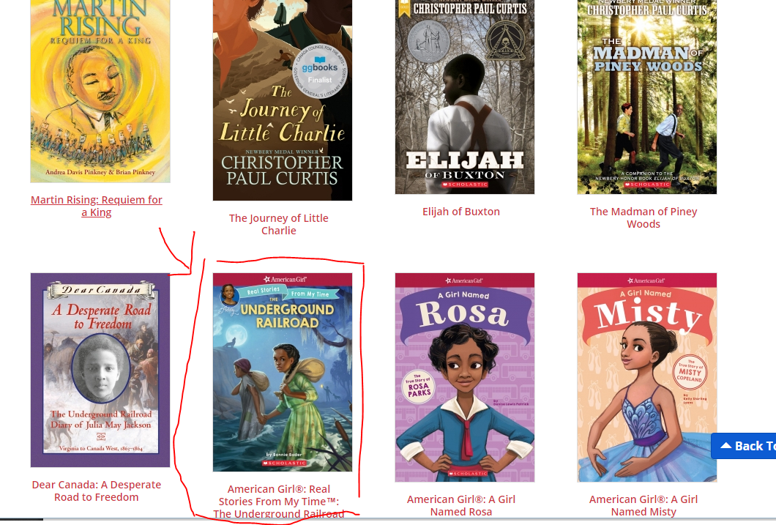

Then click on this book, and it brings me to a completely different page

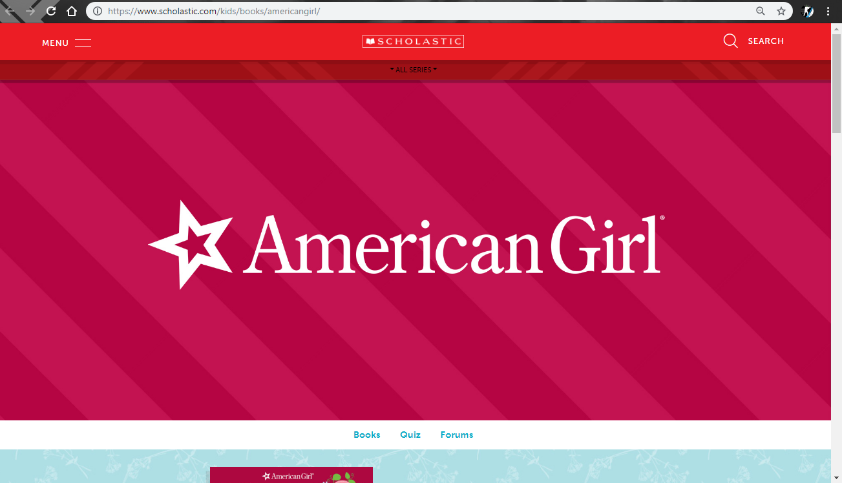

This log stays this big even if zoom out of the image, this is very bad design because I don’t want to see the logo of this company, I want to see the book I clicked on -_-

While some of the other books that have the same author (American Girl) , but no giant logo at the top 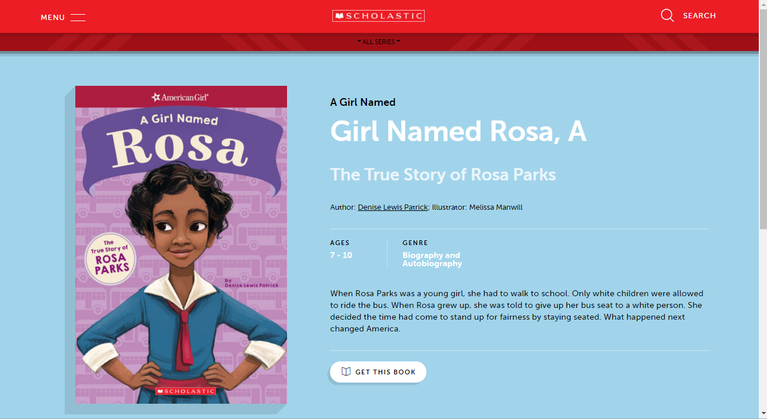

Then there are some that follow the actual scholastic website.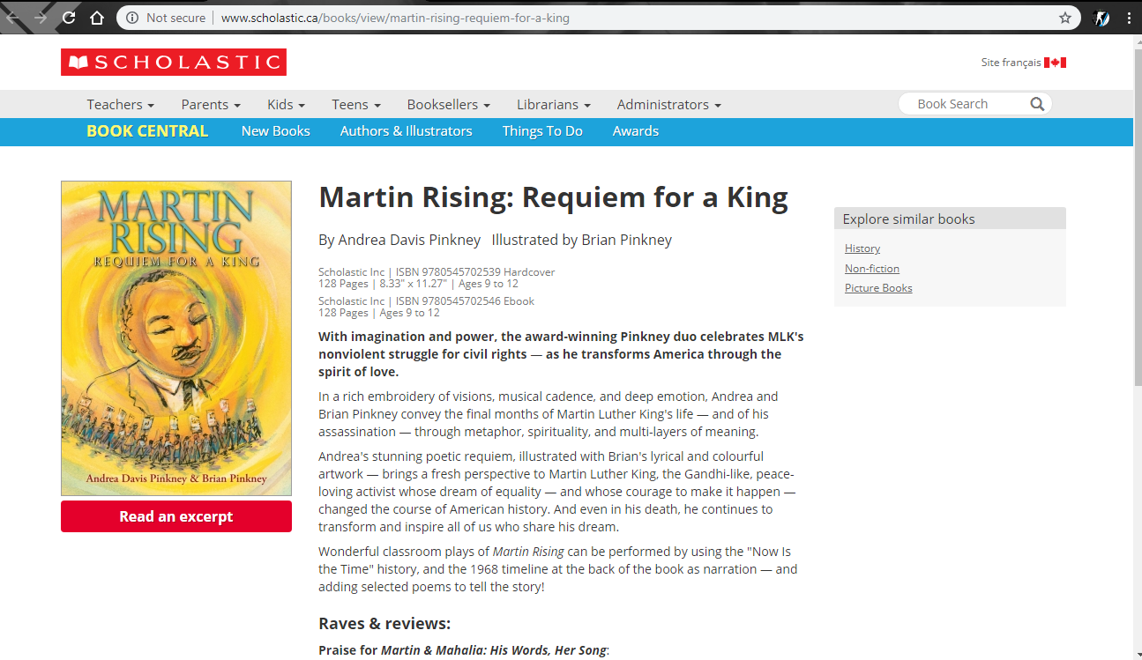

The flow of the Home of the website is completely different compared to the rest of the sites mechanics. There is only one image that makes sense and that will guide me in the correct direction towards getting a book.

When I click on the Book fair button while going through the options, I am not able to click on the tile of the book(highlighted yellow) or the picture as an interactive link, instead it is just text and I have to read the book review instead of the books information, so I can be more inclined to purchase the book.

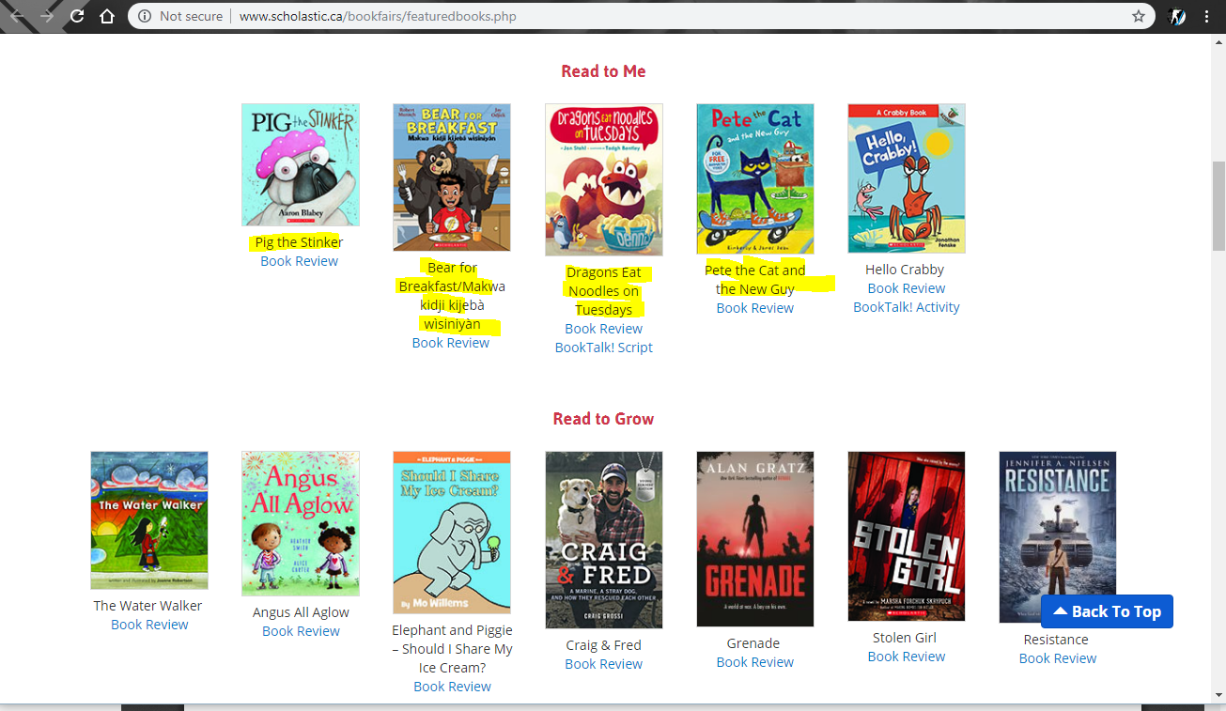

Some of the features of the website are not finished, like the bottom of the kids section does not have a favourites section which would be very beneficial for the younger audience to get books that are currently popular.

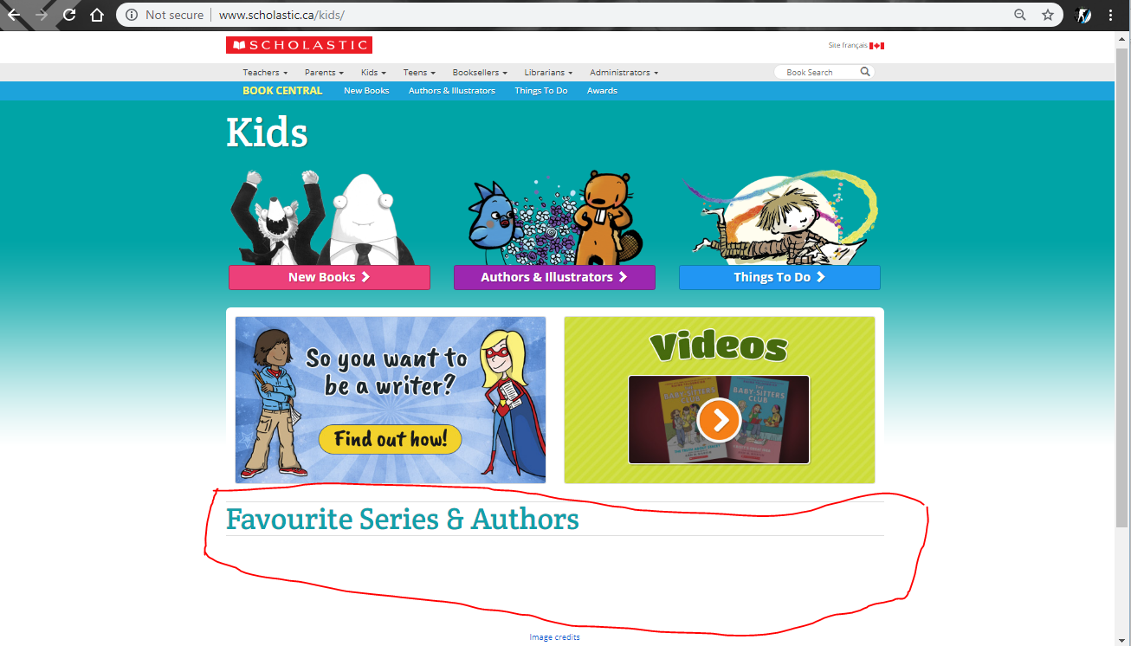

While looking through some books, I found that there was no buy or add to cart feature. Currently the only way to get books is by email, fax or

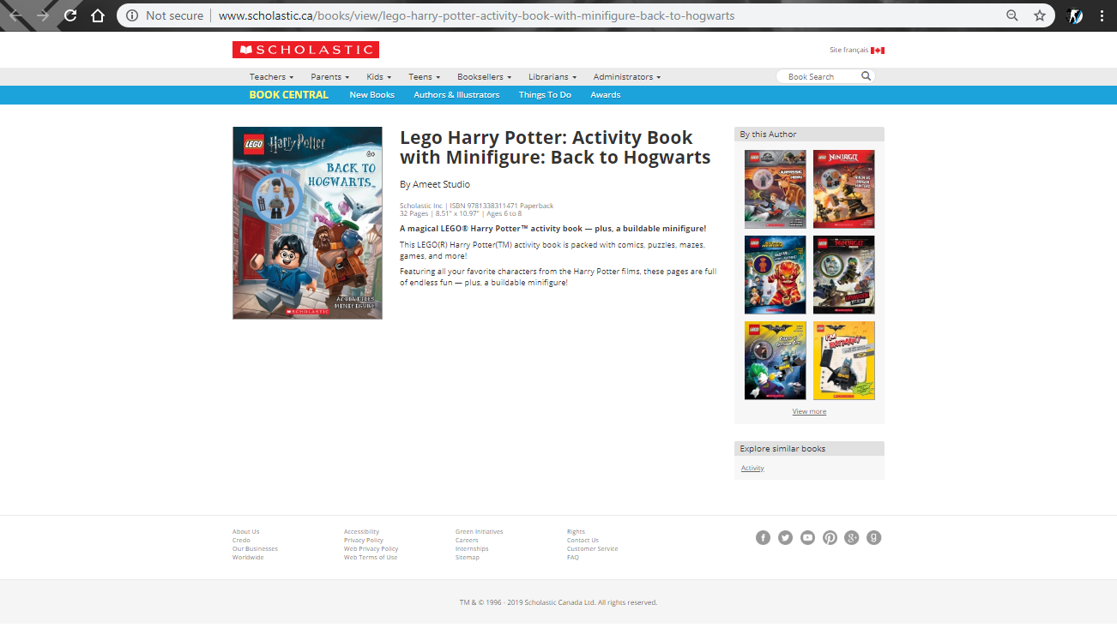

Then While looking for books, it shows yet another way to display the content. The way that they have made the website is a very poor decision on advertising books, as it could be improved by allowing a short description, or even a picture of the book organized similar to the entire rest of the website, instead of having the items like a list

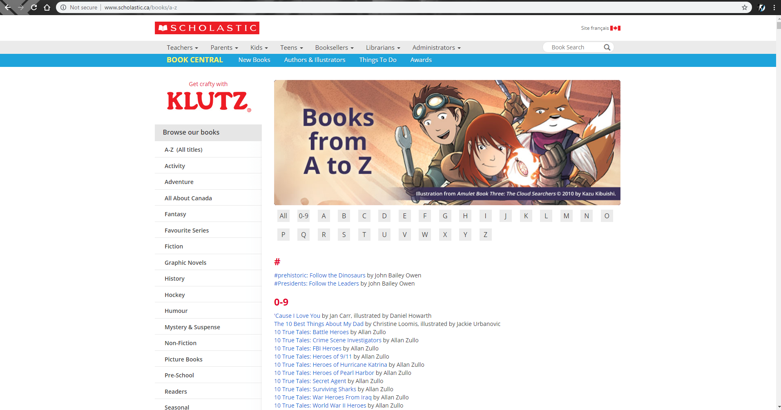

**3. The pain points of this website include**  
**Summery of the pain points**

* Bad labeling on the home page
* Not clear where to go on home page, multiple clicks instead of one
* Kids section leads you to another page, which is not needed at all and is unfinished
* The kids section has unnecessary headers and links, just taking up space and are not needed
* Some links don’t work
* In mobile display it is flawed, and takes out necessary features (navbar, links for books)
* Ridicules way to order books
* Really un appealing way to find books, only the first 6 books have images, others are links
* Pointless links that are already there
* **There is no way to buy books from the original scholastic page, unless you are a teacher or a Educational person/take the time to call scholastic and make an account**
* Some navigation labels need to be better written
* **There is also no way to buy books on the other site that scholastic said that you can purchase books, because the Icon is missing to add to cart**

**3.The pain points of the website include (More detailed report)**

* Bad labeling on the home page, I have no clue what to click when I get to the website, I am trying to find books, and have to go to the nav bar to find specific teen or kids. Instead of this I would put a most popular for teens, most popular for kids
* 
* The Kids section leads us to another page which is pointless because all of the options that are on the page are in the nav bar,

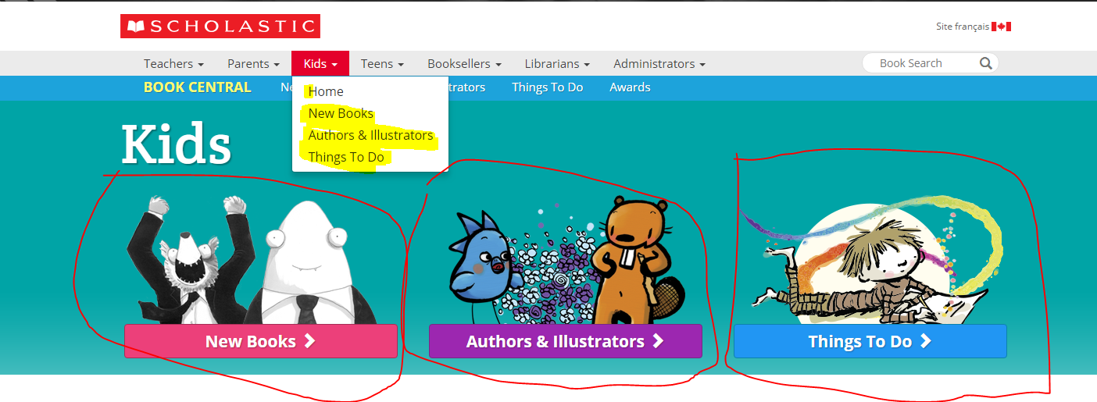

And at the bottom of the page it is incomplete.

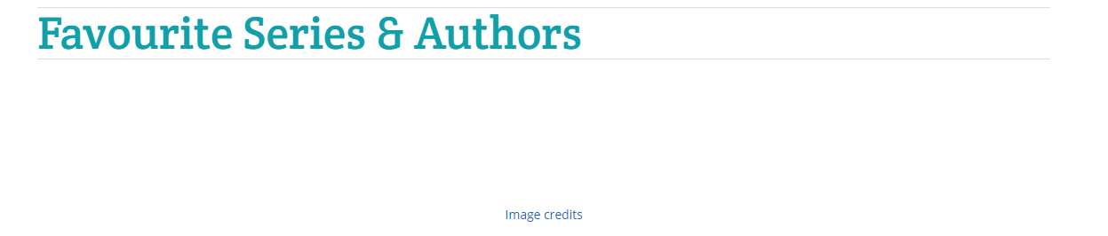

* When you go to the kids page there is a March Hot Reads, new in March and a recently released which I feel is too many links that are too similar(books are all the same)

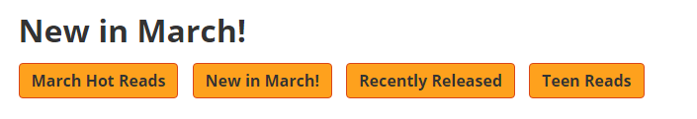

* The bar on the right giving you a rundown of the book categories is removed when the screen is small. I feel like this limits the ability of a user to navigate efficiently.

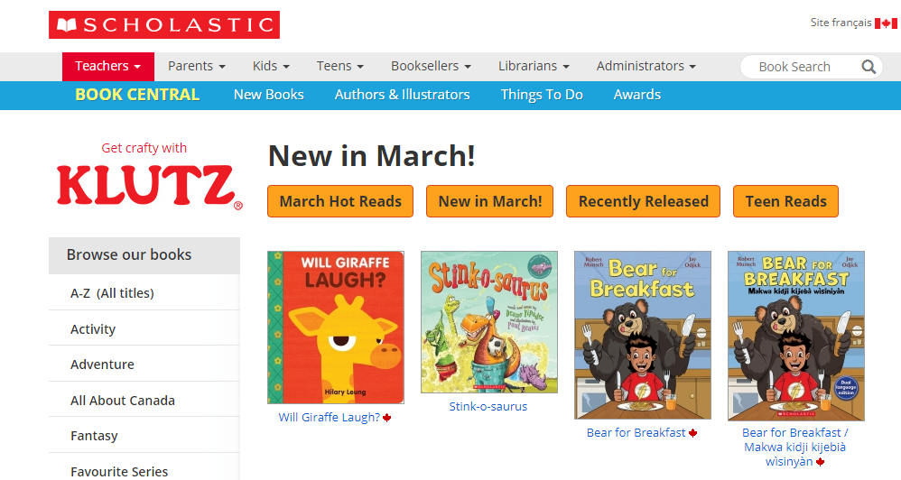

When you make it smaller

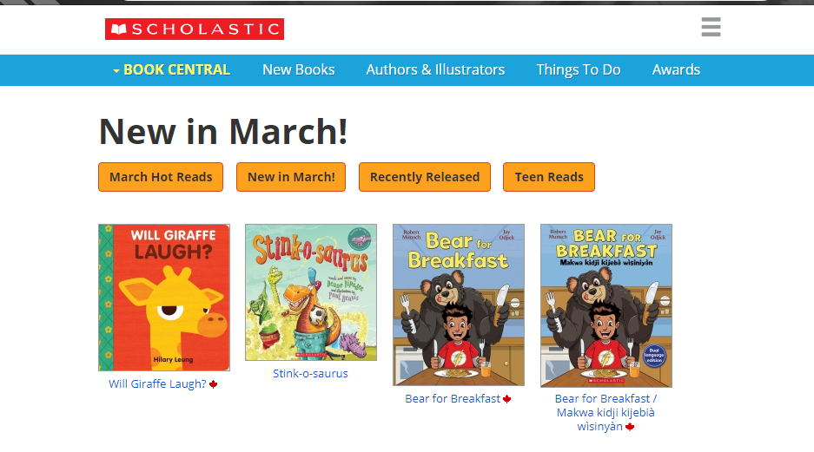

* Your only navigation to other categories is taken away, other then teen reads, this is a mistake in my opinion because you took away the categories on the left as well, allowing navigation to take even more clicks and even more time.
* A really obscure way to order books, sells books and games, but you need to be very specific and go through an emailing prosses that is not necessary and is not easy to use.
* There should be a order book button on the screen with a description of the button
* The layout for ordering a book can be made a lot better,
* There is a random crash when I click a link

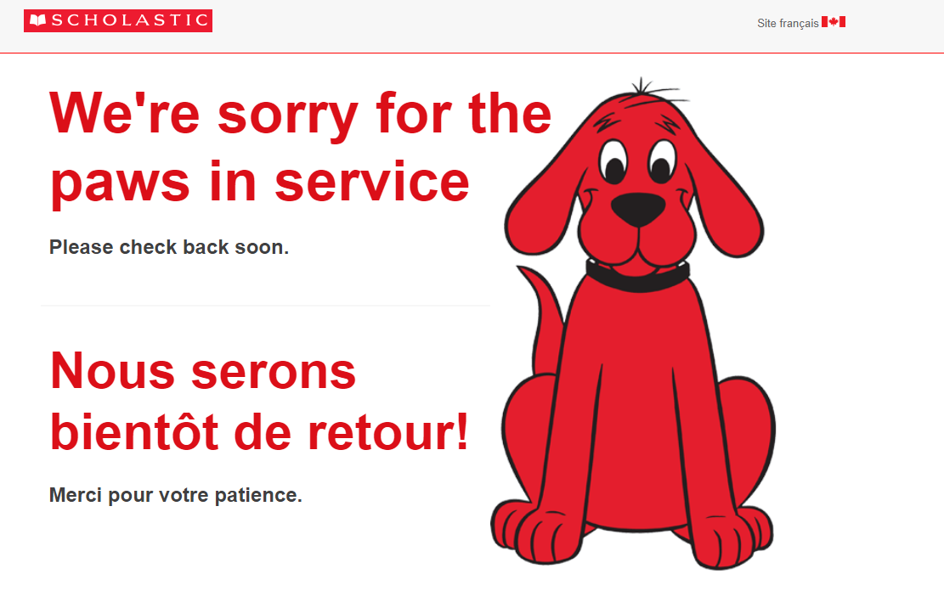

* Really un appealing way to find books, there should be an option to see items as a list, but the default should not be a list.



* For teen reads, there are only 6 books before it takes you to the list of books
* A ridicules amount of extra webpages that will confuse you and waste a lot of your time.
* The way to get books is not very straight forward and will take you a lot of time the first time you visit the website, because it is confusing on which link to click.
* A pointless link for changing the site to French in the teachers

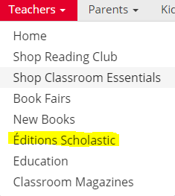

**Q4.revisit the site and give recommendations on improving the interaction, layout**

**Summery of recommendations and improvements for Scholastic**

1. Scholastics Home page recommendations needs to put labels above their pictures to allow me as a user to know where these things go
2. They need to remove useless links that are not necessary and are not the reason that the user has come to the website.
3. Scholastic needs to remove pages that are not necessary, or repeated information, that already have the information in other links
4. Scholastic needs to re format the teen and kids websites so that they show all book titles with images and authors, instead of a list of links bringing you to a page of
5. Need to make the home page much more interactive and showing you a small portion of the sections of the website (teen and kids books, educational items) from importance to not important.   
     
   to do this I would make them on one page a section for kids and a section for teens above it showing the latest of each, and a more button that would take you to the link for teens or kids if pressed
6. Remove repeated links and “book central” navbar
7. Fix the problem with different book views(some have a lot of color not going with the website, while others have no color going with the coloring scheme of the website)
8. When looking for books on the kids and teen pages, I would put all of the categories either in a nav at the top of the page instead of and “book central” **OR** on the left hand side, if its on the left it would slide out when a icon is clicked
9. Make the support more interactive to help people instead of having a pdf saying this is who to email and talk to, make It instead have to go to catalogs and order the books from there
10. Adding a feature to buy a book while you are viewing the description would be the biggest problem of the website, it is very difficult to buy a book,
11. Change the way to buy things from the website.to buy a book from the online store, you must go to catalogs and find the magazine that your book is in(if it is in it), then put in your billing information first, then find the book you want and send the order. If you put in your information wrong, red text pops up at the top of the page and is really ugly and people with bad vision would have trouble seeing it. To fix this I would make a 3 step process that is easy to follow, first find the book you want on the website itself not a specific catalogue, then I would ask for your billing information and then finalize all of the information and maybe implement a feature to save information by logging in.
12. Fixing misleading label’s on navbar
13. Fixing pages that load errors
14. The images of the books are all different sizes

Full documentation of reasons for improvements for Scholastic

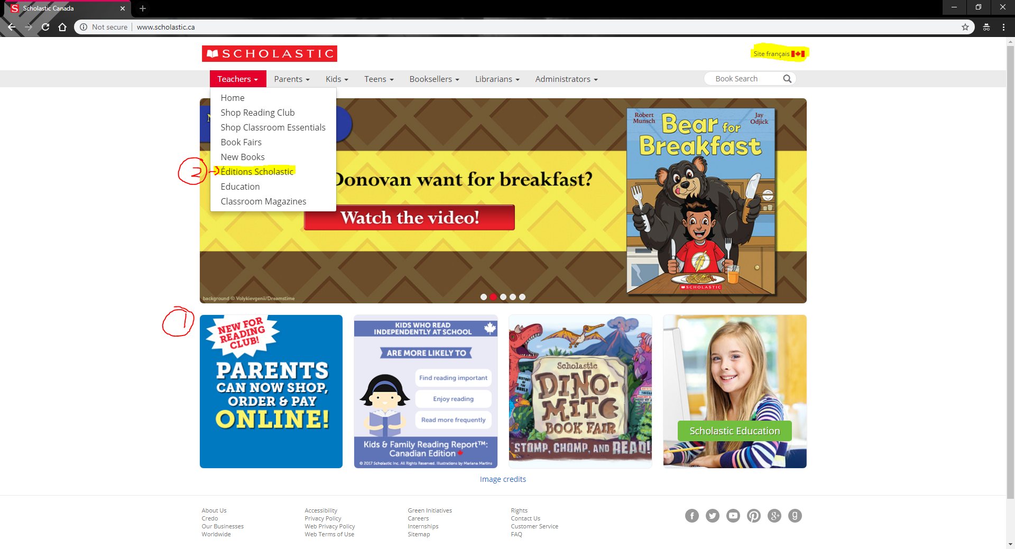

1. The pictures need labels, so I understand where to go to find books.
   1. Social Media is not in a nice place where everyone can view it
2. Not needed links are, all over the site

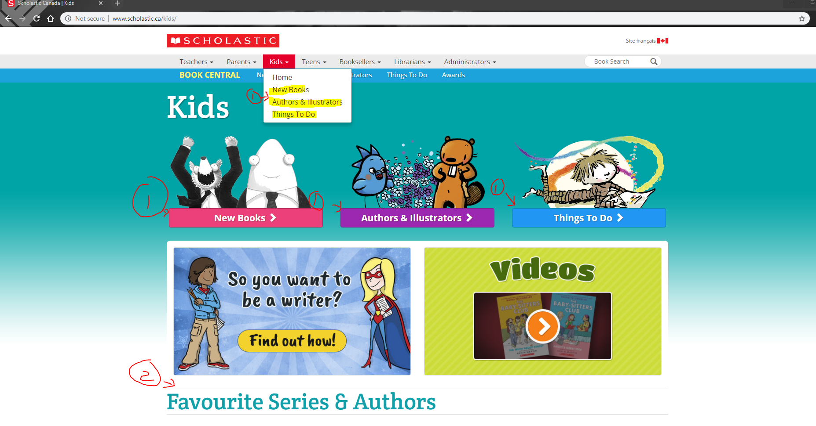

1. The labels are not necessary at all because its in the navigation links, are on the same page 3 times, it’s a bit redundant, I would remove the page and give the links only in the nav bar or the home page under the kids category.
2. The Favourite Series and Authors on this page should not be there at all, its unfinished and is not necessary to fix this I would take this page out and place the at the top of the home page of kids

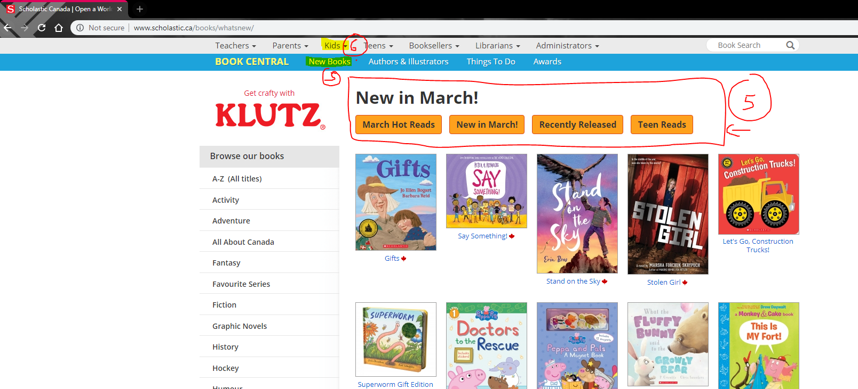

5. The orange links are really similar and should be taken out because they are way too similar and the links all show the same books so there is no point in going there unless it is teen, which If I wanted to go to that category I could do it from the navigation bar, so it is redundant, I would remove this feature and put this in the new books tab which would have new books for kids, new books for teens exedra…

6. I would take out book central because its in the navigation bar, the only one I might keep is awards, but that could be a small section on the main page instead.

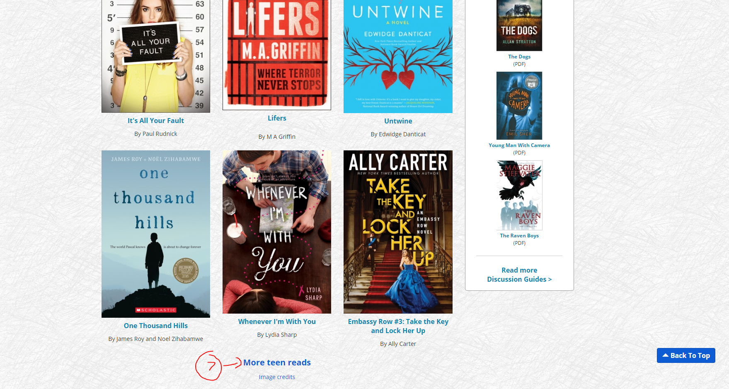

7.does not continue the trend of having images throughout the pages, brings me to a link, I would keep the same style and continue loading the books with images. Instead of a list



8.I would fix the unnatural flow of some of the book pages, and make all of them similar



9.I would add an add books to cart feature, and allow you to order it directly from the website

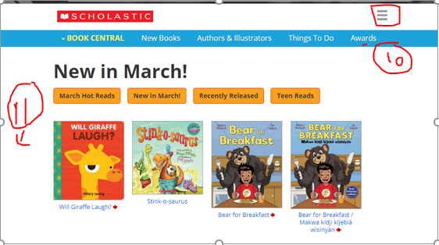

10. I would take the original navigation bar and replace it with the blue one

11. I would add the options to go into the other categories with a sliding menu that opens when clicked, like what is in the square on problem 10 is, but add it on the left side

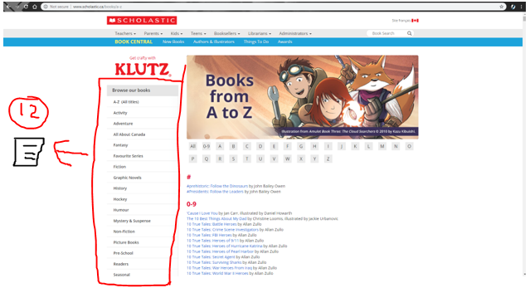

12. make the list of books a more efficient and much more appealing interface so that the users can look through and pick books based on covers, titles and authors instead of just a blank list of items. Change it so then the categories(fiction, Mystery, sci-fi…) are in a side menu that can be clicked for them to appear

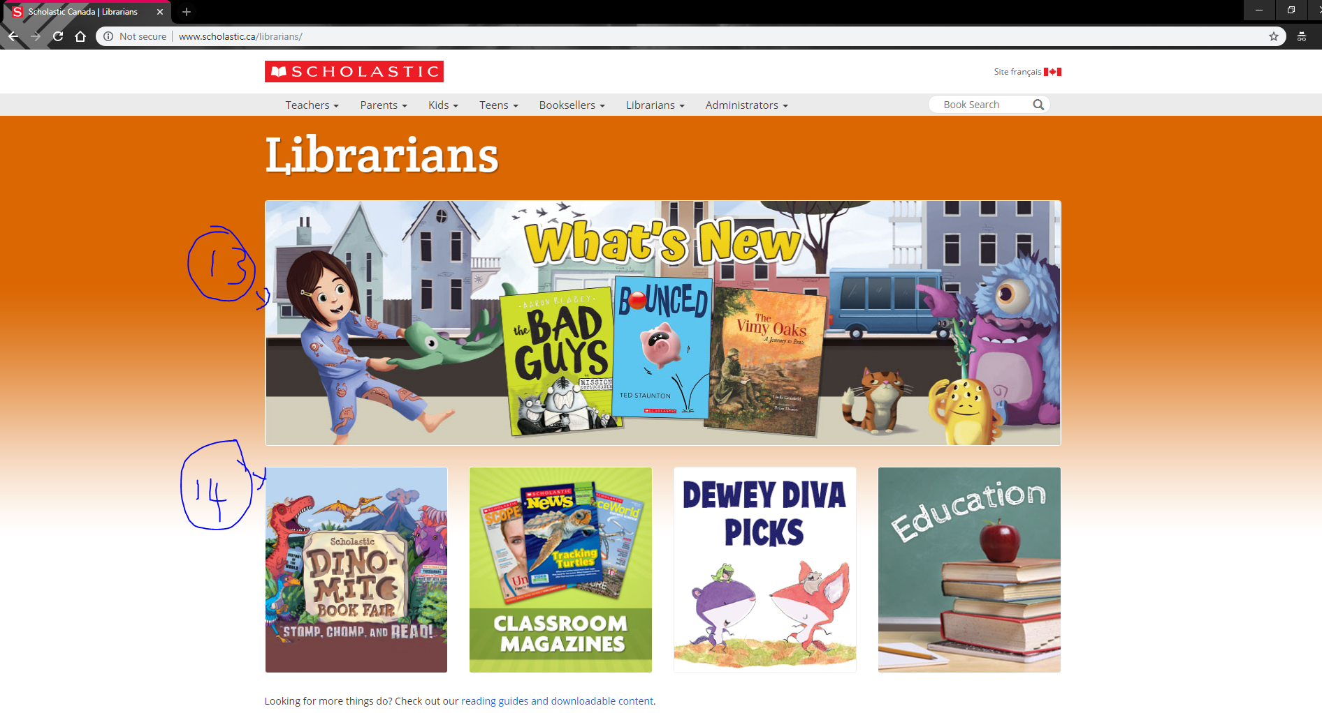

13. will take you to what’s new for kids, and not teens, does not tell you which it will take you to, I would remove this page entirely because these links are given in the navigation bar too many times, as well as the site does not help you as a librarian decide something that would help you.

14. Take out not necessary links like Librarian, which is already repeated in the opening homepage or other pages like teacher and parents,

15.the support pages need work because they all send you to pdf’s which no one will be willing to go through because there are better and easier websites to navigate

16. remove any links that cause an error page

17. Make it so that you can add books to a cart from the book’s information,

18.The Navigation and Administrators navigation labels can be named better



19. And make sure that navigations, don’t have the same link to the same page.

**Q5.What type of improvements beyond what is on the site would you recommend?**

1. I would recommend adding a order now button that would be located at the end of the description of every book that you click on, this would significantly increase sales, and would increase your websites efficiency and income.

2. The other thing I would add is the ability to log in this would allow me to save my billing information and allow other users to efficiently come back to get more information and books quicker and easier.

3. I would ask for emails so then you can send the monthly brochures to people’s/parents emails, so they can be reminded people to read and buy books and always keep learning, this can notify you on a particular author or book series, if they publish a new book comes out, they would send you an email informing you of information.

4.an about me page that will tell your customers what your website does and what you want to accomplish and why

5.addding the ability to add things to a cart and buy multiple books from the website, without having to choose books from the magazines

6. A wish list to add books/games.

7. Add a filters feature that will allow you to search by feature

**Q6. What type of improvements or features would be recommended for repeat visitors**

I think that the first improvement for repeat visitors would be including a optional login page so then they don’t have to save billing information, they can save favourite books and series, allowing them to get a notification if a new book publishes by the author…